Project

In

Math

Submitted by:  
Audrey Nicole D. Iñigo

Submitted to:  
Mrs. Violeta SM. San Pedro

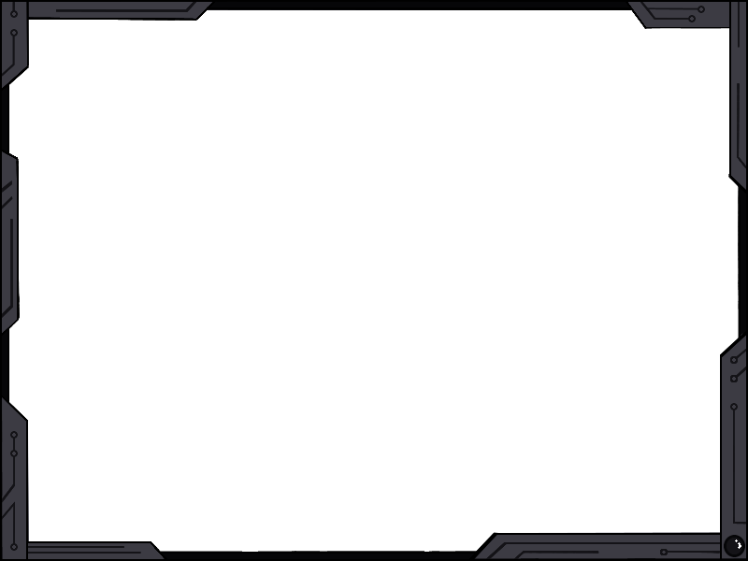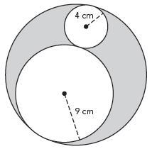Find the area of the shaded portion.

1.

26 cm

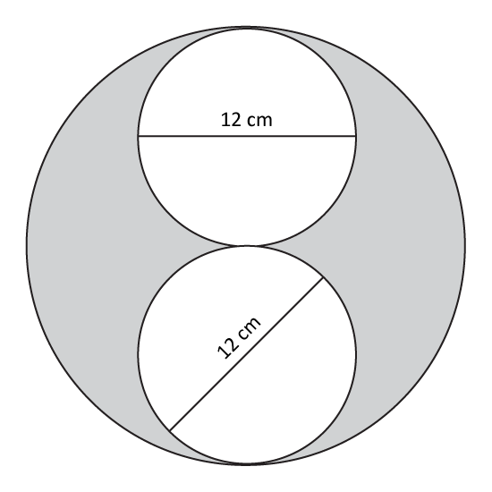Find the area of the shaded portion.

2.

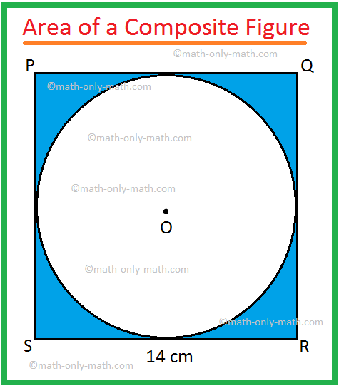Find the area of the shaded portion.

3.

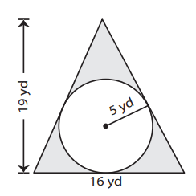Find the area of the shaded portion.

4.

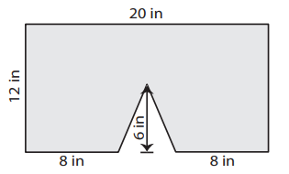Find the area of the shaded portion.

5.

